

B. TECH. II SEM. SESSION –2023 SUBJECT: ENGINEERING CHEMISTRY
IMPORTANT QUESTIONS

PART A

Q1.What is Hardness?
A1.The characteristic properties of water which prevent the lathering of soap, due to presence of certain salts of calcium, magnesium and other heavy metals (like Al⁺³, Fe⁺³and Mn⁺²) dissolved in water”. It was originally define as “the soap consuming capacity of a sample of water”.

Q2. What do you mean by degree of hardness?
A2. The degree of hardness of water is expressed in term of equivalent amount of CaCO3. Although hardness of water is never present in the form of calcium carbonate because it is insoluble in water and hardness is actually caused by bicarbonates, chlorides and sulphates of calcium and magnesium.
Equivalent of CaCO3 = Weight of h.p.s × equivalent weight of CaCO3/
Equivalent weight of h.p.s
CaCO3 as the standard for reporting hardness of water is due to its molecular weight which is exactly 100 and equivalent weight is 50. The equivalent of CaCO3 for hardness producing substance can be calculated as-
Or
Equivalent of CaCO3 = M.F × Weight of h.p.s

Where: h.p.s = hardness producing substance
M.F = Multiplication Factor

Q3. What is Green Solvents?
A3. Green solvents- The solvents which are inert, have low toxicity, easy to recycle without contaminating the products are called green solvent. The solvent selected should not have any negative impact on the environment or human health. e.g. halogenated solvents like CHCl3, CCl4 are suspected carcinogens and to avoid their use, green alternatives like water, cyrene, isopropanol, ionic liquids, supercritical CO2 have been used.

Q4.What is role of Gypsum in Cement? A4. Role of gypsum
Tri calcium aluminate (C3A) combines with water very rapidly.

C3A + 6H2O C3A .6H2O + heat
After the initial setting, the paste becomes soft and the added gypsum retards the dissolution of C3A by forming insoluble calcium sulpho aluminate.
3CaO.Al2O3 + XCaSO4.2H2O 3 CaO.Al2O3.X CaSO4.2H2O
This reaction prevents the high concentration of alumina in the cement solution and hence retards the early initial setting of cement

Q5. What is significance of Annealing?
A5. Annealing is a process of slow cooling of hot glass objects after they have been formed, to relieve residual internal stresses introduced during manufacture. On sudden cooling upper layer cool down first, leaving inner portion in a state of stress. By annealing process glass is made stable, for the long term, in finished form.
Annealed glass will not break as long as it is not subjected to sufficient outside force.
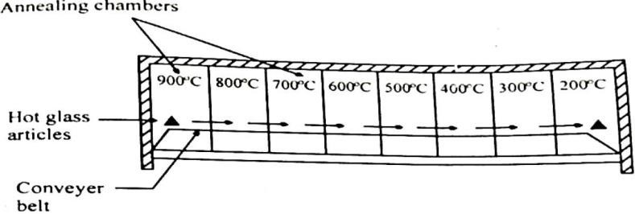
ANNEALING PROCESS

Q6. Define Alkaline or non-alkaline hardness.
A6.Alkaline or Temporary or Carbonate hardness: This type of hardness caused due to the presence of bicarbonates and carbonates of calcium and magnesium in water and can be removed simply by boiling.
Ca(HCO3)2 ^{boil} CaCO3 + H2O + CO2
Mg(HCO3)2 ^{boil} Mg(OH)2 + H2O + CO2

Non-alkaline or permanent or Non-Carbonate hardness: It is due to the presence of sulphates and chlorides of Ca, Mg, and other heavy metals and cannot be removed by boiling. It is removed by the use of chemical agents.
CaCl2 + Na2CO3 CaCO3 + 2NaCl

Q7. What do you mean by Green chemistry?
A7. Green Chemistry-The design of processes that reduce or eliminate the production of toxic products is known as green chemistry. The term was first used by Paul T. Anastas .

Green Chemistry implies:
- Prevention of pollution rather than treatment of pollution
- Environmentally Benign Chemistry
- Sustainable Chemistry
- Ecofriendly Chemistry
- Clean Chemistry

Q8. What is Viscosity index?
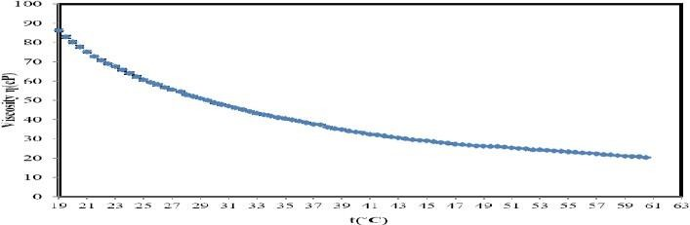
A8. Viscosity Index - The variation of viscosity of a liquid with temperature is called viscosity index. A relatively small change in viscosity with temperature is indicated by high viscosity index whereas, a low viscosity index shows, a relatively large change in viscosity with temperature.
Viscosity Index

Q9.What is Pitting corrosion?
A9. Pitting Corrosion- Pitting corrosion is a localized attack where the corrosion dissolute the metal, forming pits or holes. Pitting is usually, the results of the breakdown or cracking of the protective film on a metal at specific points. This type of corrosion is dangerous because it is difficult to detect due to the corrosion products that may cover the pits, difficult to design against the formation of pits, as well as to predict when this type of corrosion may occur. The electrochemical oxidation–reduction process of pitting corrosion on surfaces of metals in an aqueous media is shown as-
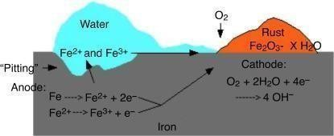

Pitting Corrosion
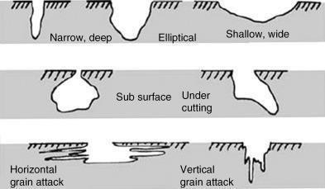

Types of Pits

At Anode removal of electrons takes place

Fe Fe⁺² + 2e⁻
At the cathode area oxygen takes up electrons to form hydroxy ions-
½O2 + H2O + 2e⁻ 2 OH⁻
Overall chemical reaction is-
½O2 + H2O + 2Fe 2Fe(OH)2

Q10.What is the requisites of drinking water? A10. Requisites of Drinking water:
The common specifications for drinking water are given below.
Physical: It should be clear and odourless.
- Should be pleasant to taste and perfectly cool.
- Its turbidity should not exceed 10ppm.
Chemical: Should be free from harm full gases like H₂S.
- Its P^{H} should be in the range of 7.0-8.5.
- Chloride and Sulphate should be less than 250ppm.
- Total hardness and Total dissolved solids (TDS) should be less than 500 ppm.
- Fluoride content should be less than 1.5.
Biochemical: It should be free from pathogens

Q11.What is the Calgon conditioning?
A11.Calgon conditioning: - Calgon [sodium hexametaphosphate Na2 [Na4P6O18] is added to boiler water which prevents the scale formation by forming the soluble complex with calcium sulphate.
2CaSO4 (Boiler water) + Na2 [Na4P6O18] [Na2CaP6O18]⁻² + 2Na2SO4
Highly soluble complex

Q12. What is unit of hardness?
A12. Unit of hardness of water is expressed in following concentration terms.
- Parts Per million (ppm): It is a part of CaCO3 equivalent hardness per 10⁶ parts of water.
- Milligram per liter (mg/liter): It is defined as the number of milligram of CaCO3equivalent hardness present in one liter of water that is :

1 mg/lit = 1 mg of CaCO3 equivalent hardness in one liter of water1 mg/lit = 1 ppm
- Degree Clarke (ºCl): It is define as number of grains (64.8mg) of CaCO3 equivalent hardness per gallon (4.55L) of water. i.e. a parts of CaCO3 equivalent hardness per 70000 part of water.

1 ºCl = one part of CaCO3 per 70000 part of water
- Degree French (ºFr) : It is a part of CaCO3 equivalent hardness per lac (105) part of water that is :

1 ºFr = 1 part of CaCO3 equivalent hardness per 10⁵ parts of water

Q13.What do you mean by setting and hardening in cement?
A13. Cement when mixed with water forms a plastic mass called cement paste. During hydration reaction, gel and crystalline products are formed. The inter-locking of the crystals binds the inert particles of the aggregates into a compact rock like material.
This process of solidification comprises of following steps
- Initial and Final Setting
- Hardening

1) Initial and Final Setting- When cement is mixed with H2O a plastic cement paste obtained. This paste gradually losses its plasticity and finally becomes stiff and hard. It is known as setting.
Initial setting of cement is mainly due to the hydration of tricalcium aluminates and tetra calcium alumina ferrite constituensts. Dicalcium silicate also contributes to initial setting, forming gel on hydrolysis.
Dicalcium Silicates- It hardens slowly and its effect on strength occurs in days. This is due to its slower rate of reaction with water.

2(2 CaO.SiO2) + 4H2O 3 CaO.2SiO2.6H2O + Ca(OH)2 +250 KJ/Kg

Tricalcium Silicates- It is highly responsible for initial setting and early strength as it hardens rapidly as per the reaction below.

2(3CaO.SiO2) + 6H2O 3 CaO.2SiO2.3H2O + 3Ca (OH)2 +500 KJ/Kg
Tobermonite gel
The hydral gel thus formed is responsible for the binding action between the aggregates.
Tricalcium Aluminates- This compound is firstly hydrates and gained strength within 24 hours and hydration is completed in 7 days.

3 CaO.Al2O3 + 6 H2O 3 CaO.Al2O3.6 H2O + 880 KJ/Kg

The presence of gypsum in the cement helps to retards the speed of the initial set. This is due to the formation of calcium sulphoaluminate which does not show any tendency to rapid hydration.

3CaO.Al2O3 + XCaSO4.2H2O 3 CaO.Al2O3.X CaSO4.2 H2O
Tetracalcium alumina ferrate- It is assets in the manufacture of Portland cement by allowing low clinkering temp. It hydrates very rapidly.

4CaO.Al2O3.Fe2O3 + 7 H2O 3CaO.Al2O3.6 H2O+ CaO.Fe2O3.H2O+ 420KJ/Kg

Hardening- Hardening is relatively slow process after the final set, the solid begins to gain strength and it increases its strength which is called hardening. Hardening of strength depends upon the chemical combination of cement and water.

Q14. Write properties and used of Borosilicate glass. A14. Borosilicate glass or Pyrex glass or Jena glass Raw Materials
- Silica
- Small amount of alumina
- Alkali metal oxide
- Boron trioxide
Properties:
- Low thermal co-efficient of expansion.
- High softening point and excellent resistivity(shock proof)
- High chemical resistance
Uses:
Industrial pipeline for corrosive liquids, gauge glasses, superior laboratory apparatus etc.

Q15. Define corrosion.
A15.Corrosion -Corrosion of metals is defined as the spontaneous destruction of metals in the course of their chemical or electrochemical interactions with the environment. Thus, it is exactly the reverse of extraction of metals from ores.
Corrosion is the process of gradual deterioration of metal from its surface due to unwanted chemical or electro chemical reaction of metal with its environment.

Q16. Why chromium is used for coating iron?
A16. Chromium is less reduction potential so more reactive then iron. When iron is coated with chromium then chromium is corroded and protects the iron from corrosion.
In this coating of base metal (to be protected) takes place by dipping the base metal (cathodic in nature) into the molten chromium (anodic in nature).

Q17.What is rust.
A17. During Corrosion Iron convert into compound and form rust
Rusting of iron -A layer of reddish scale and powder of oxide is formed on the surface of iron metal.

2Fe + 2H2O + O2 → 2 Fe(OH)2
4Fe(OH)2 + O2 → 2(Fe2O3.2H2O)

Q18. What do you mean by Carbonization?
A18. Carbonization of coal: When coal is heated strongly in absence of air, it forms a strong, porous, dense, lustrous and coherent mass known as coke.
The process of conversion of coal into coke is called carbonization. There are two types of carbonization:
- LTC (Low Temperature Carbonization)
- HTC (High Temperature Carbonization)

Q19. What do you mean by Octane number?
A19. Octane number: The quality of fuel is determined by its Octane number. Octane number of petrol can be defined as the percentage by volume of iso-octane in the n-heptane and iso- octane mixture in the fuel.
The resistance offered by gasoline to knocking cannot be defined in absolute terms. It has been found that n-heptane knocks very badly and hence its antiknock value (Octane number) has been given ZERO. On the other hand iso-octane (2,2,4- tri methyl pentane) gives very little knocking, so its anti-knock value is given as 100.
H3C-CH2 - CH2 - CH2 - CH2 - CH2 – CH3
n- Heptane Octane number-0
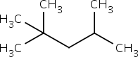

Iso-Octane
Octane number-100
Q20. What is synthetic petrol?
A20.Synthetic petrol is obtained from coal liquification in which solid coal is converting into liquid. Petrol is generally synthesized by the following two methods
- Fischer tropsch method
- Bergius method

Q21. What is the Tining?
A21. Cathodic metal coating (Tinning):
Metal coating which is cathodic to base metal, known as cathodic metal coating. In order to protect a metal from corrosion, any metal (cathodic in nature) which is lower in the galvanic series like Sn, Cu, Ni etc, are coated on the surface of metal (base metal/ anodic in nature). The best example of cathodic metal coating is Tinning.
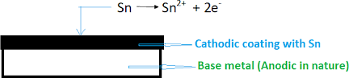

Tinning is a process in which coating of base metal (to be protected) takes place by dipping the base metal (anodic in nature) into the molten Tin (cathodic in nature).

Uses:
- Tin coated iron or steel articles or utensils are used for storing and preparing of foodstuffs.
- It is most widely used for protection of iron or steel from atmospheric corrosion in the form of roofing sheets, pipes, etc

Q.22 What is cracking in petroleum?
A22.Cracking - It is defined as the decomposition of high molecular weight hydrocarbon of high boiling point into simple lower molecular weight hydrocarbons of low boiling point. For example,

C10H22 (Decane) C5H12 (n-Pentane) + C5H10 B. P. =174°C B.P. = 36°C

Q23. What is Knocking in IC engine?
A23.Knocking- Knocking is a sharp metallic sound similar to ratting of a hammer produced in internal combustion engine due to uneven or unsteady or uncontrolled combustion of air gasoline mixture.
In an internal combustion engine when the rate of oxidation becomes so high that the last portion of the
fuel-air mixture gets ignited instantaneously, producing an explosive violence known as knocking. A good quality gasoline should resist knocking. The knocking order of different hydrocarbon is -
Straight chain paraffin > branched chain paraffin > olefins > cyclo paraffins > aromatics.

Q24. What are GCV and LCV?
A24. Calorific value: Calorific value of a fuel is defined as “The total quantity of heat liberated, by the complete combustion of unit mass of fuel”.

Types of calorific value

- Gross or Higher calorific Value (HCV): The total amount of heat generated when a unit mass or unit volume of fuel is completely burnt and the product of the combustion are cooled down to room temperature.

GCV = Heat liberated from combustion + Latent Heat
- Net or Lower calorific Value (LCV): The net heat produced when unit mass or unit volume of the fuel is completely burnt and the products of combustion are allowed to escape”.
LCV = GCV- Latent heat of water vapour produced

LCV = GCV- mass of hydrogen ×9×latent heat of steam (587 kcal/kg)

Q25. What is priming?
A25. When steam is produced rapidly in the boiler, some droplets of the liquid water are carried along with the steam. This process of wet steam formation is called “Priming Causes”.
Priming is caused by:
- The presence of considerable quantities of dissolved solids.
- Steam velocities high enough to carry droplets of water in to the steam pipe.
- Sudden boiling
- Faulty design of boiler.

Prevention:
- Controlling rapid change in steaming velocities.
- The proper design of boilers.
- Ensuring efficient softening

Q26. What is Foaming?
A26. It is the formation of small but persistent foam or bubbles at the water surface in boiler which do not break easily.
Causes of Foaming: it is caused by the presence of oil in boiler feed water.
- Presence of alkali in boiler feeds water
- Oils and alkaline react to form soap which greatly lower the surface tension of water and thus increases the foaming tendency of the liquid.

Q27. Explain the causes of hardness in water?
A27. Cause of Hardness: Hardness of water is due to the presence of calcium and magnesium salts generally, soap consist of sodium salt of higher fatty acids such as stearic, oleic and palmitic, which are highly soluble in water and thus exert their cleaning action. If calcium and magnesium salts are present in water, these react soluble sodium soap to form insoluble salt of calcium and magnesium.
2 C17H35COONa + CaSO4 (C17H35COO)2Ca + Na2SO
(Sodium Stearate) (Calcium Stearate)
(Soluble salt ) (Insoluble salt ) ppt

2C17H35COONa + Mg Cl2 (C17H35COO)2 Mg + NaCl
(Sodium Palmitate) (Magnesium Palmitate)
(Insoluble salt ) ppt

The white scum or precipitate of insoluble soap of calcium and magnesium is formed. Lather is not produced until the cations, Ca⁺² and Mg⁺² are completely precipitate out in the form of insoluble salts.

Q28. Write notes on reforming?
A28. Reforming of Gasoline: The process of structural modification by which anti-knocking properties can be improved is called reforming.
Reforming is the process of rearrangement of straight chains of hydrocarbon in the ring compound

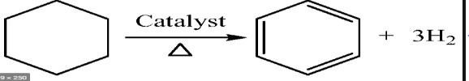
Example- Dehydogenation

Dehydocyclization

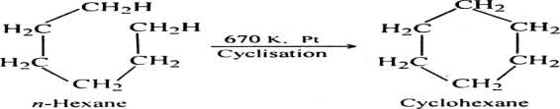

Q29. What is the Vitrification
A29. Glass exhibits property of vitrification
Vitrification is the process of conversion of molten glass to an amorphous solid instead of forming crystalline solid on slow cooling.

Q30. What is Dulong’s formula?
A30. Dulong's formula for calorific value from the chemical composition of fuel is:

HCV = 1/100 [8,080 C + 34,500 (H – O/8) + 2,240 S] kcal/kg

where C, H, O, and S are the percentages of carbon, hydrogen, oxygen and sulphur in the fuel respectively. In this formula, oxygen is assumed to be present in combination with hydrogen as water.
H2 + 1/2O2 H2O

2g 16g 18g
1g 8g 9g

Total mass of hydrogen in fuel – fixed hydrogen
Total mass of hydrogen in fuel – (1/8) mass of oxygen in the fuel
∴ 8 part of oxygen combine with 1 part of hydrogen to form H2O. Fixed hydrogen = 𝑀𝑎𝑠𝑠 𝑜𝑓 𝑜𝑥𝑦𝑔𝑒𝑛 𝑖𝑛 𝑡ℎ𝑒 𝑓𝑢𝑒𝑙
8
Then the amount of hydrogen available for combustion
= total mass of hydrogen in fuel – fixed hydrogen
= [H-O/8]

Q31. What is Cetane no.?
A31.Cetane number: Cetane number of diesel oil may be defined as the percentage of cetane (n- hexadecane) in a mixture of cetane and α-methyl napthalene. It measures the ease with which the fuel (diesel fuel) will ignite under compression. So higher the cetane number better is the ignition property of the fuel.
The order with decreasing cetane number is as follows n-alkanes > napthalene > alkenes > branched alkanes > aromatics.
The combustion of fuel in a diesel engine is not instantaneous but there is some lag. The interval between the start of fuel injection and its ignition is called ignition delay or induction lag. Cetane has very short ignition delay compared to any diesel fuel whereas α-methyl napthalene has a longer ignition delay.
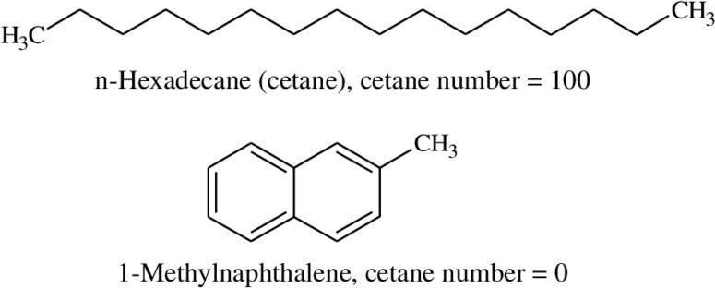

Q32.What is Metallurgical Coke?
A32.METALLURGICAL COKE -The process of preparing coke from coal is known as carbonization of coal. When bituminous coal is heated strongly in the absence of air, the dense, strong, porous mass obtained is called metallurgical coke.

Q33. What is scale and sludges?
Sludge- When precipitation takes place in the form of loose, non adherent and slimy precipitate, it is called sludge.
Scale-If the precipitated matter forms a hard, adhering coating on the inner walls of the boiler, it is called scale.
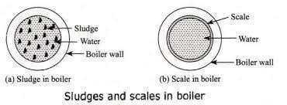

Q34. What is fractional distillation of petroleum? A34. Fractional distillation of crude oil
Fractional distillation separates a mixture into a number of different parts, called fractions.
A tall fractionating column is fitted above the mixture, with several condensers coming off at different heights. The column is hot at the bottom and cool at the top. Substances with high boiling points condense at the bottom and substances with lower boiling points condense on the way to the top.
Crude oil is a mixture of hydrocarbons. The crude oil is evaporated and its vapours condense at different temperatures in the fractionating column. Each fraction contains hydrocarbon molecules with a similar number of carbon atoms and a similar range of boiling points.

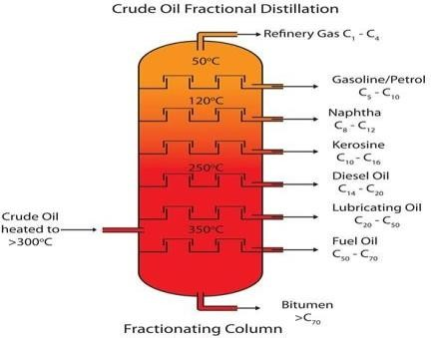

Fractional distillation of crude oil
Q35.What do you mean by Green Chemistry and Sustainable Development? A35.Green Chemistry and Sustainable Development
Development that meets the needs of the present without compromising the ability of future generations to meet their own needs.
Sustainable development means improving our social and environmental footprint at every stage of production of product from raw materials.

Green Chemistry and Sustainability
Green chemistry is a tool in achieving sustainability
  - Minimize deterioration of environment
  - Enhance utilization of renewable resources
  - Save natural resources
  - Lower greenhouse gas emission & enhance healthy environment.
  - Fundamental approach to pollution prevention
PART B

Q1. What is lubricant? Discuss various types of mechanism of lubrication?
A1. A Lubricant is defined as a Substances which apply between two moving and sliding surface to reduce friction between them are known as Lubricants” and the process by which friction between sliding surface is reduce, known as Lubrication.
The metal surface is not smooth as its looks. In actual metals looks irregular having peaks (called asperities) and depression (called valleys). In machine, the friction is aries when metal metal surface are rubbed against each other. Due to friction large amount of energy is liberated in the form of heat which reduces the efficiency of machine
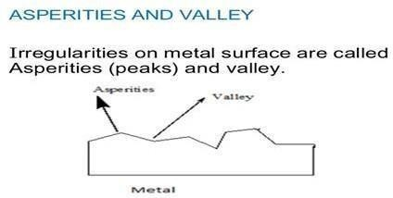

Mechanism of Lubrication
- Thick Film or Fluid Film or Hydrodynamic Lubrication -It is carried out with the help of liquid lubricants. In this mechanism, two moving and sliding surfaces are separated by thick film of lubricant fluid of about 1000A°, applied to prevent direct surface to surface contact and consequently reduce wearing and tearing of metals. Therefore it is known as thick film or fluid film lubrication or hydrodynamic (hydro meaning liquid and dynamic meaning relative motion) lubrication. In this case fluid is formed by mixing of hydrocarbon oils and anti-oxidants with long chain polymer so as to maintain viscosity. Fluid film lubrication is useful in delicate and light machines like watches, clocks, guns, scientific equipments.

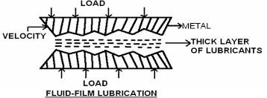
- Thin Film or Boundary Lubrication - It is carried out with semi-solid (grease) and solid (graphite and molybdenum disulphide) lubricants. Boundary lubrication is a condition in which the lubricant film becomes too thin to provide total separation. In this type of lubrication a thin film of lubricant is adsorbed on the surface by weak Vander Waals forces. Thin film lubrication is operating at relatively low speed and heavy loading (pressure).
This type of lubrication used in bearings, gears, piston rings, pumps etc
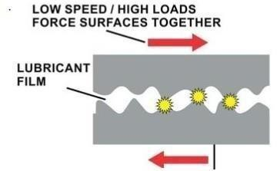

- Extreme Pressure (or Temperature) Lubrication - In this mechanism, moving or sliding surfaces are under high pressure and speed, therefore this is known as extreme pressure lubrication. In such a case high temperatures generated due to friction, under these condition liquid lubricants are fail to stick and decompose or vaporize. These problems are minimized by special additives are added to mineral oils. These additives form durable films on metal surfaces which can withstand high loads and high temperatures. Important additives are organic compound having group like chloride, sulphur, phosphorus etc. They react with metallic surface to form metallic compound (possess high melting points and serve as good lubricants under extreme temperatures and pressures) like chlorides, sulphides, phosphate as more durable film.

Q2. What is caustic Embrittlement and carry over in steam boiler?
A2. Caustic Embrittlement: Caustic Embrittlement is the phenomenon during which boiler materials becomes brittle due to accumulation of caustic substance. It takes place in high pressure boiler due to presence of highly alkaline water.
During softening process, calculated quantity of Na2CO3 is added which decomposed to give sodium hydroxide and CO2 due to sodium hydroxide boiler water becomes “caustic”.

Na2CO3 + H2O → 2NaOH + CO2

The caustic embrittlement can be explained by the formation of the conc. cell. The iron surrounded by concentrated NaOH becomes anodic side, which is corroded whereas the iron surrounded by dil. NaOH becomes cathodic side.
At high temp. in cracks and joints under stress, this concentrated NaOH dissolves iron and form Sodium ferrate.

Fe +2NaOH → 2 Na2FeO2 + H2O

This sodium ferrate at high temp. decomposed into NaOH and Fe3O4 thus again NaOH regenerate which further dissolve iron.

2 Na2FeO2 + 4H2O → 6NaOH+ Fe3O4+ H2O
Prevention: Caustic embrittlement can be prevented by following majors.
- By using sodium phosphate as softening reagent instead of sodium carbonates.
- By adding tannin or lignin to boiler water which blocks the cracks in the boiler walls.
- By adding sodium sulphate to boiler water, Na2SO4 also blocks cracks thereby preventing deposition of caustic soda solution in these.

Q3. What is synthetic petrol? Explain the manufacturing of petrol by fischer Tropsch method process?
A3. Synthetic petrol is obtained from coal liquification in which solid coal is converting into liquid.
Fischer-Tropsch Process: - Water gas is a mixture of carbon monoxide and hydrogen (CO+H2), produced by passing steam over red hot coke. It is mixed with hydrogen. The gaseous mixture (water gas
+ hydrogen) is purified by passing over Fe2O3, to remove H2S, then passing over Fe2O3, Na2CO3 mixture to remove organic sulphur compounds. The purified gas is compressed to 5 to 25 atm at 200-300°C passed through a converter containing catalyst cobalt, thorium, magnesium and kieselguhr. A mixture of saturated and unsaturated hydrocarbons is formed.
C + H2O CO + H2
n CO +2nH2 CnH2n + nH2O.
n CO +(2n+1)H2 CnH2n+2 + nH2O.

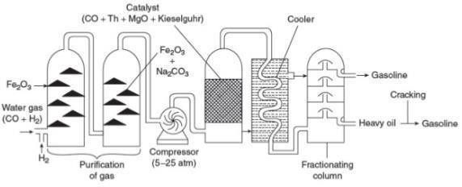
The out coming hot gaseous mixture is cooled in a cooler where a liquid resembling crude oil is obtained which is then subjected to fractionation to yield gasoline and heavy oil. The heavy oil is reused for cracking to get more gasoline.
Fischer-Tropsch Process

Q4. What is Boiler corrosion? A4. Boiler corrosion:
Boiler corrosion is decay or disintegration of boiler body material either due to chemical or electro- chemical reaction with its environment.

Disadvantage of Corrosion:
- Shortening of boiler life
- Leakage from the joint and rivets.
- Increased cost of repairs and maintenance

Causes of boiler corrosion are:
1) Dissolved oxygen: Water usually contains about 8 ppm of dissolved oxygen at room temperature. Dissolved oxygen in water, in presence of high temperature, attacks boiler material.

Removal of dissolved oxygen
2Fe + 2H2O + O2 → 2 Fe(OH)2
4Fe(OH)2 + O2 → 2(Fe2O3.2H2O)
- By adding the hydrazine or sodium sulphite or sodium sulphide Thus,
N2H4 + O2 → N2 + 2H2O

(Hydrazine)
2Na2SO3 + O2 → 2 Na2SO4

(Sodium sulphite)
Na2S + 2O2 → Na2SO4

(Sodium sulphide)
- By mechanical de-aeration, in this process water spraying in a perforate plate- fitted tower. Removal of dissolved O2 is ensured by applying high temperature and vacuum (according to Henry Law).
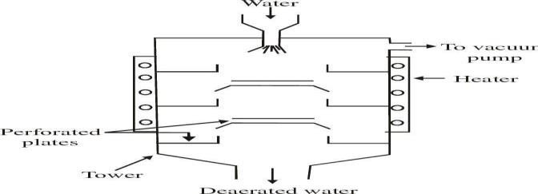

TOWER FOR MECHANICAL DEAERATION OF WATER

Dissolved carbon dioxide : There are two sources of CO2 in boiler water viz, dissolved CO2 in raw water and CO2 formed by decomposition of bicarbonates in H2O.
Mg(HCO3)2 → MgCO3 + H2O + CO2

Carbon dioxide in presence of water forms carbonic acid which has a corrosive effect on the boiler materials like any other acid.
H2O + CO2 → H2CO3

Removal of CO2:
- By mechanical deaeration along with O2.
- By filtering water through limestone.
CaCO3 + H2O + CO2 → Ca(HCO3)2
- By addition of appropriate quantity of ammonium hydroxide
CO2 + NH4OH → (NH4)2CO3 + H2O

Q5. Define the Cathodic protection?
A5.Cathodic protection- The principle involved in this method is to be force the metal to be protected to behave like a cathode. There are two types of cathodic protections-
- Sacrificial anodic protection: In this protection method, the metallic structure to be protected (base metal) is connected by a wire to a more anodic metal so that all the corrosion occurs at that anodic metal and metallic structure (cathode) is protected. The more active metal so employed is called sacrificial anode. The corroded sacrificial anode is replaced by a fresh one, when consumed completely. Metals commonly employed as sacrificial anode are Mg, Zn, Al and their alloys which possess low reduction potential (more reactive) and occupies higher end in electrochemical series. The underground water pipelines and water tanks are also protected by sacrificial anode method.
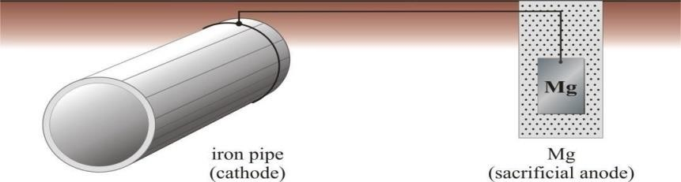

The anodic protection with sacrificial anode
- Impressed current cathodic protection: In this method, an impressed current from external source is applied in opposite direction to neutralize the corrosion current, and convert the corroding metal from anode to cathode. Thus the anodic corroding metal
becomes cathodic and protected from corrosion. The impressed current is deriving from the external DC source. The negative terminal of DC source is connected with metal to be protected whereas the positive terminal of DC is connected to the anode. Here anode may be graphite, stainless steel, scrap iron etc. The impressed current protection method is used for water tanks, water & oil pipe lines, transmission line towers etc.

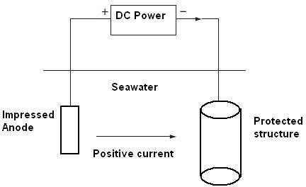
Impressed cathodic protection

Q6. Explain the mechanism of dry corrosion. A6.DRY OR CHEMICAL CORROSION:
This type of corrosion is due to the direct chemical attack of metal surfaces by the atmospheric gases such as oxygen, halogen, hydrogen sulphide, sulphur dioxide, nitrogen or anhydrous inorganic liquid, etc. The chemical corrosion is defined as the direct chemical attack of metals by the atmospheric gases present in the environment
Example: (i) Silver materials undergo chemical corrosion by atmospheric H2S gas. (ii) Iron metal undergo chemical corrosion by HCl gas.

TYPES OF DRY OR CHEMICAL CORROSION:
- Corrosion by Oxygen or Oxidation corrosion
- Corrosion by Other gases
- Liquid Metal Corrosion

CORROSION BY OXYGEN/OXIDATION CORROSION:
Oxidation Corrosion is brought about by the direct attack of oxygen at low or high temperature on metal surfaces in the absence of moisture. Alkali metals (Li, Na, K etc.,) and alkaline earth metals (Mg, Ca, Sr, etc.) are rapidly oxidized at low temperature. At high temperature, almost all metals (except Ag, Au and Pt) are oxidized. The reactions of oxidation corrosion are as follows:

Mechanism:
  - Oxidation takes place at the surface of the metal forming metal ions M^{n+}
2M → 2M^{n+} + 2ne⁻
  - Oxygen is converted to oxide ion (O²⁻) due to the transfer of electrons from metal. n/2 O2 + 2n e- → n O²⁻
  - The overall reaction is of oxide ion reacts with the metal ions to form metal oxide
film.
2 M + n/2 O2 → 2 M^{n+} + nO²⁻
The nature of the oxide formed plays an important part in oxidation corrosion process.
Metal + Oxygen → Metal oxide (corrosion product)

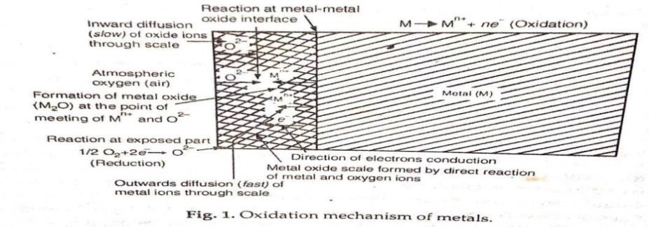

When oxidation starts, a thin layer of oxide is formed on the metal surface and the nature of this film decides the further action. If the film is-
- Stable: A Stable layer gets adhered tightly to the parent metal surface. Such a film behaves as protective coating in nature, thereby shielding the metal surface. The oxide films on Al, Sn, Pb, Cu, etc., are stable, tightly adhering and impervious in nature.
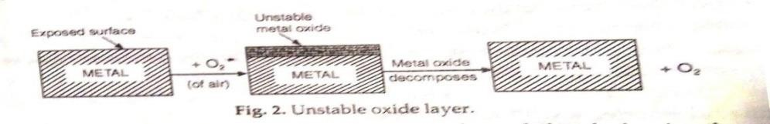
- Unstable oxide layer: This is formed on the surface of metals such as Ag, Au, Pt. As the metallic state is more stable than oxide, it decomposes back into the metal and oxygen. Hence, oxidation corrosion is not possible with noble metals.
- Volatile oxide layer: The oxide layer film volatilizes as soon as it is formed. Hence, always a fresh metal surface is available for further attack. This causes continuous corrosion. MoO3 is volatile in nature.
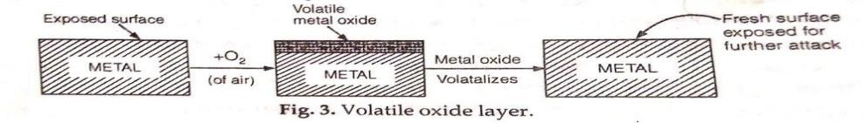

Porous layer: The layer having pores or cracks. In such a case, the atmospheric oxygen has access to the underlying surface of metal, through the pores or cracks of the layer, thereby the corrosion continues till the entire metal is completely converted into its oxide.
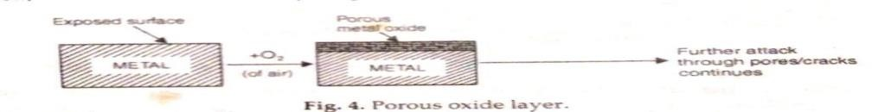

Q7. What is Pilling Bedworth Rule.
A7. Pilling – Bedworth rule: The oxide layer acts as a protective or non–porous barrier, if the volume of the oxide is more than the volume of the metal from which it is formed. On the other hand -if the volume of the oxide layer is less than the volume of metal, the oxide layer is porous and hence non-protective because it cannot prevent the access of oxygen to the fresh metal surface below.

Specific volume ratio = Volume of Metal oxide/ Volume of metal

“Smaller the specific volume ratio, greater the oxidation corrosion”.
For eg: alkali and alkaline earth metals like Li, Na, K, Mg forms oxides of volume less than volume of metals. These layers are porous and non-protective. Hence these undergo corrosion more rapidly. On the other hand metals like Al forms oxide whose volume is greater than the volume of the metal. Therefore Al forms a tightly – adhering non-porous protective layer.

Q8. What is the Gavanization and why food packing articles not galvanized? A8.Anodic metal coating (Galvanization):
Metal coating which is anodic to base metal, known as anodic metal coating. In order to protect a metal from corrosion, any metal (anodic in nature) which is higher in the galvanic series like Zn is coated on the surface of metal (base metal/ cathodic in nature). The best example of anodic metal coating is Galvanization. Galvanization is a process in which coating of base metal (to be protected) takes place by dipping the base metal (cathodic in nature) into the molten zinc (anodic in nature).

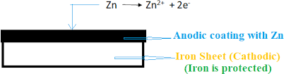
Uses: - Roofing sheets, wires, pipes, bolts, screws, buckets, tubes etc. which are made of iron are protected from atmospheric corrosion by galvanizing them.
Food packing articles not galvanized because galvanized utensils cannot be used for preparing and storing food stuffs, especially acidic zinc gets dissolved in all acids forming highly toxic compounds.

Q9. Explain ultimate analysis method of fuels. A9.Ultimate analysis:-

Ultimate analysis is involving the measurement of C, H, N, S, and O.
- Carbon and hydrogen: In a combustion apparatus, about 1-2 gram of coal sample isburnt in dried oxygen to convert C and H into CO2 and H2O respectively.
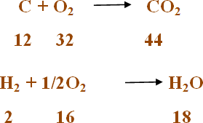

After this gaseous product of combustion passed to KOH and anhydrous CaCl2 tubes of known weight. The gaseous products CO2 and H2O are absorbed in KOH and CaCl2 tubes of known weights, respectively. The increase in weights of these (KOH and CaCl2) are then determined.
2KOH + CO2 K2CO3 + H2O
CaCl2 + 7H2O CaCl2.7H2O

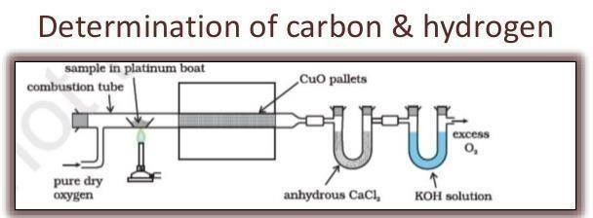

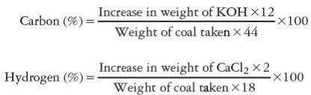
- Nitrogen: In Kjeldahl’s flask add accurately weighed powdered coal and heated with concentrated H2SO4 and K2SO4 as a catalyst. The solution becomes clear when all the
nitrogen is converted into ammonium sulphate then it is treated with excess of NaOH which convert ammonium sulphate into ammonia; the liberated ammonia is distilled over and absorbed in a known volume of standard (N/10) H2SO4 solution. From the volume of H2SO4 used by liberated ammonia, the percentage of Nitrogen in coal, calculated as follows:
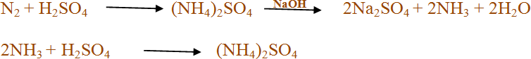
The volume of unused H2SO4 is then determined by titrating (back titration) against standard NaOH solution (N/10).

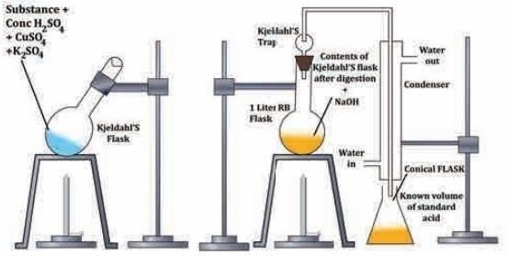

KJELDAHL’S METHOD

The percentage of nitrogen can be determined using the given formula:

Percentage of nitrogen = 1.4 x volume of acid used x Normality of acid(N/10)
Weight of coal taken
- Sulphur: A known amount of coal sample is burnt in bomb calorimeter in presence of oxygen. After that, sulphur present in coal is converted into sulphate. The ash obtained from the bomb calorimeter, is extracted with dil. HCl. The washings (acid extracts) are treated with Barium chloride solution and the sulphates are precipitate as Barium sulphate. This precipitate is filtered, washed, dried and heated to obtain constant weight.
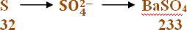

Percentage of Sulphur = Weight of BaSO4 x 32 x 100
Weight of coal sample x 233
- Ash- The percentage of ash determined as –

% of ash = weight of ash formed ×100

weight of sample

- Oxygen: It is determined by subtracting the sum of total % of carbon, hydrogen, nitrogen, sulphur and ash from 100.

% of oxygen = 100 – [% carbon + % hydrogen + % nitrogen + % sulphur + % ash] Significance of Ultimate Analysis:
- Greater the % of C and H, better is the coal in quality and calorific value.
- Nitrogen is an inert and incombustible gas and doesn't contribute in calorific value.
- Sulphur is also contribute in calorific value but it is undesirable because it pollute the atmosphere by SO2 and SO3.
- Oxygen content decreases the calorific value of coal. High oxygen content coals are characterized by high moisture and volatile matter. Thus a good quality coal should have low% of oxygen.

Q10. Explain manufacture of gasoline by Bergius method.
A10. Bergius Process: - Coal is powdered and made into a paste with heavy oil and a catalyst is mixed with it. This mixture is sent to a converter maintaining at 400-500°C and a pressure of 200- 250atm, where it meets the hydrogen. Hydrogenation takes place to form higher hydrocarbons. These are further decomposed to produce lower hydrocarbons. When these lower hydrocarbons are passed through a oil and heavy oil. The middle oil is subjected to hydrogenation in presence of a catalyst to produce more gasoline. The heavy oil is recycled to make a paste with fresh coal powder.
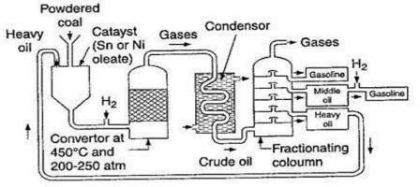
Bergius Proces

Q11. Explain Refining of petroleum.
A11. Refining of Petroleum: - Petroleum obtained from the ground is a mixture of oil and unwanted impurities (water, dirt, sulphur compounds, etc). The process of removal of impurities from crude oil and separation of various fractions with different boiling ranges is called oil refineries. The whole process of refining of petroleum involves the following steps.

Step-1: Separation of water (Cottrell‘s process):-
The crude oil is an emulsion of oil and salt water. It is allowed to flow through two highly charged electrodes. The colloidal water droplets coalesce to form large drops which separate out from the oil. Step-2: Removal of sulphur compounds:-
Sulphur compounds have objectionable properties of pollution. When the crude oil is treated with copper oxide, a reaction occurs with sulphur compounds which results in the formation of copper sulphide ppt which is then removed by filtration

Q12. Explain purification of water.

Purification of water:
Rivers, lakes and well are the most common source of water used by
municipalities. The treatment method depends directly on the impurities present. For removing various types of impurities the following treatment processes are employed.
Screening: In this process removing floating materials like wood pieces, leaves etc. from water. Sedimentation: The process of removal of suspended impurities by allowing the water to stand undisturbed for 2-6 hours in big tank is known as sedimentation.
Most of the suspended particles settle down at the bottom of tank due to force of gravity and they are removed. 70-75% of the suspended matter is removed during this process. The tank where the flow of water is retarded is called the setting or sedimentation tank.
Sedimentation and Coagulation: In this process, fine suspended and colloidal particle are removed by addition of requisite amount of chemical (as coagulants) to water before sedimentation. Coagulants like alum or ferrous sulphate produce Al⁺³, Fe⁺³ ions which neutralized the oppositely charged colloidal and clay particles amount of chemicals. Some common chemical used as coagulating are as follows:
Al2(SO4)3 + 3Ca(HCO3)2 2Al(OH)3 + 3CaSO4 +6CO2
(Coagulant)
NaAlO2 +2H2O 2Al(OH)3 + NaOH SODIUM ALUMINATE
Filtration: Filtration is the process of removing insoluble, colloidal and bacterial micro-organism etc. Filtration is carried out by sand filter.
A sand filter consists of tank with top layer of fine sand placed over coarse sand layer and gravels. During filtration, the sand pores get clogged due to retention of impurities in the process which can be removed by regeneration process.
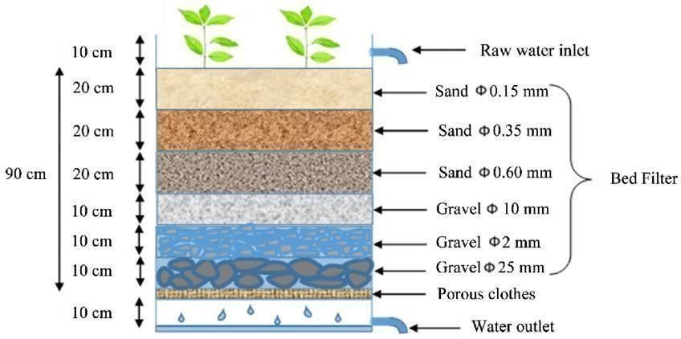

SAND FILTER

Disinfection and Sterilization or Removal of micro organism: “The process of destroying killing the pathogenic micro-organism from water is known as disinfection.” By this process removed the micro organism and make safe water for drinking.
Disinfection by Chlorine or Bleaching Powder: Chlorine is a most common disinfectant in water treatment. Chlorine may be added in the form of bleaching powder and added to water its formed HOCl (hypochlorous acid) which act as a powerful germicide.
CaOCl2 + H2O Ca(OH)2 +Cl2

Cl2 + H2O HCl + HOCl
HOCl + Bacteria Bacteria are killed
Disinfection by Chloramine: Chloramine has better bactericidal action and more stable than chlorine.
ClNH2 + H2O HOCl + NH3
Cl2 + NH3 ClNH2 +HCl
(Chloramine)
Disinfection by UV Rays: UV radiation emitted from electric mercury vapour lamp is capable of disinfection of water. This process is particular useful for disinfection of swimming pool water. This is highly expensive.
Disinfection by Ozone: Ozone is a powerful disinfectant and is absorbed by water. Ozone is highly unstable and decomposes to give nascent oxygen which is capable of destroying bacteria.
O3 O2 + [O] (Nascent oxygen)
By Potassium permanganate: KMNO4 used for sterilization of water.

Q13. Explain break point chlorination.

A13. Breakpoint Chlorination:
Break point chlorination is the chlorination of water to such an extent that not only living organisms but also organic impurities present in water are completely destroyed.
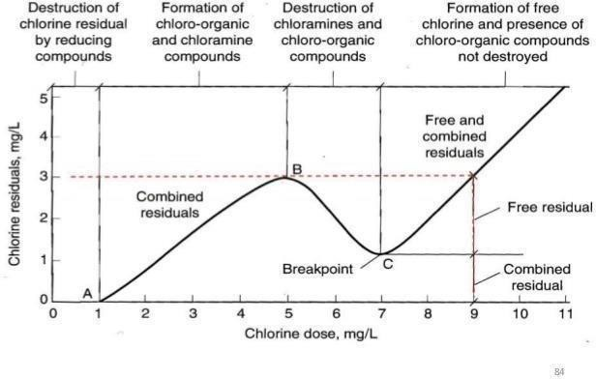
“Break point is the point at which free residual chlorine begins to appear”. When chlorine is added to water, it is used for oxidation of reducing compound present, chlorination of organic impurities, free ammonia and disinfection of bacteria.

Break Point Chlorination takes place in four stages;-
Stage I- In the first stage, chlorine used in very low dose and no free residual chlorine since all the added chlorine gets consumed for complete oxidation of reducing substance present in water.
Stage II- As the amount of chlorine increases there is steady increase in the amount of residual chlorine also. This stage corresponds to the formation of chloro-organic compound & chloramines.
Stage III- At still higher doses of applied chlorine, oxidation and destruction of organic compounds and micro organism sets in, consequently, the amount of free residual chlorine also decreases. When the oxidative destruction is complete, it reached a minima.
Stage IV -After minima, the added chlorine is not used in any reaction. The residual chlorine keeps increasing in direct proportion to added chlorine.
Hence, for effectively killing the micro-organisms, sufficient chlorine has to be added. Addition of chlorine in such dosage is known as Break Point Chlorination.

Q14. Write notes on-
- Cetane No.

Antikocking agents.

- Cetane number: Cetane number of diesel oil may be defined as the percentage of cetane (n- hexadecane) in a mixture of cetane and α-methyl napthalene. It measures the ease with which the fuel (diesel fuel) will ignite under compression. So higher the cetane number better is the ignition property of the fuel.
The order with decreasing cetane number is as follows n-alkanes > napthalene > alkenes > branchedalkanes > aromatics.
The combustion of fuel in a diesel engine is not instantaneous but there is some lag. The interval between the start of fuel injection and its ignition is called ignition delay or induction lag. Cetane has very short ignition delay compared to any diesel fuel whereas α-methyl napthalene has a longer ignition delay.



- Anti-knocking agents: knocking is decreases by adding some compounds to fuel known as anti- knocking agents. For example: tetra ethyl lead (TEL) and iron carbonyl. Tetra ethyl lead (TEL) Pb(Et)4 known as anti-knock agents. Under combustion, TEL produces Pb and PbO. These particles act as free radical chain inhibitor as they arrest the propagation of the explosive chain reaction responsible for knocking.

Q15. What is Oil gas? Explain manufacturing of oil gas.
A15. Oil gas: Oil gas burns with smoky flame. It is mixture of hydrogen and lower hydrocarbons. It is obtained by cracking thermal decomposition of kerosene oil.
C12H26 CH4 + C2H6 + C2H4 –+C2H2 + C(tar)

(Kerosene oil) (Mixture of lower hydrocarbons)

Composition of oil gas

CH4 = 25-30%
CO = 10-15%,
CO2 = 3%
H2 = 50-55%

Manufacturing Process:
- Kerosene oil is fed in to a strong iron retort which is enclosed in a coal fired furnace.
- At the mouth of retort, a bonnet is fixed through a molten lead seal.
- The bonnet is then attached a hydraulic main form where a pipe leads to the gas holder.
- The Kerosene oil which is fed in to the red hot retort immediately gets cracked in to a number of lower gaseous hydrocarbons.
- Pure gas can be collected over the gas holder.
- The proper cracking of the oil is assessed from the colour of the gas the produced which should have a golden colour.
- Finally, the gas mixed with air and supplied to the place of burning.
Properties: Oil gas burns with smoky flame and Calorific values about 4500-5400 k cal/m³.

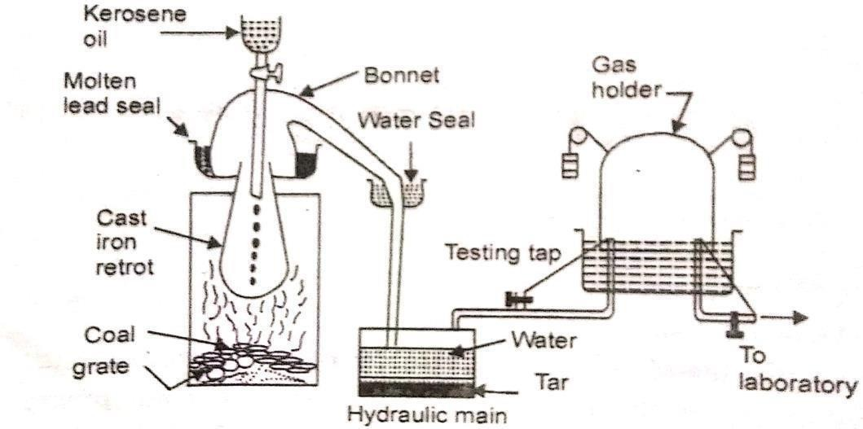
MANUFRACTURE OF OIL GAS

Q16. Explain Reverse Osmosis. A16. Reverse Osmosis Process
Osmotic pressure is the minimum pressure required to stop solvent flow through the semi permeable membrane. Therefore, when the solution side (the side where the solute concentration is high) is subjected to a pressure greater than the osmotic pressure, the solvent particles on the solution side move through the semi permeable membrane to the region where the solute concentration is low. Such inverse solvent movement through the semi permeable membrane is called reverse osmosis.
It is important to note that the pressure applied to the solution side must be higher than the osmotic pressure for the reverse osmosis process to proceed.
Osmotic pressure is a colligative property, which depends on the concentration of the solution. In water purification, the reverse osmosis process is very important. Many water purifiers used today use reverse osmosis in the purification process as one of the steps.
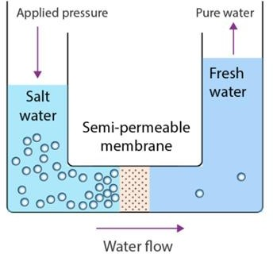

Advantage of Reverse Osmosis
- This process can be used to effectively remove many types of dissolved and suspended chemical particles as well as biological entities (like bacteria) from the water.
- This technique has a wide application in treating liquid wastes or discharge.
- It is used in purifying water to prevent diseases.
- It helps in the desalinating seawater.
- It is beneficial in the medical field.

Disadvantages of Reverse Osmosis
- Cellulose acetate membranes have limited pH tolerance. They degrade at temperatures greater than 35ºC. They are vulnerable to bacteria. They eventually hydrolyze.
- Polyamide membranes are intolerant of temperature greater than 35ºC. They have poor tolerance for free chlorine.

Q17. Explain use of alternative feedstocks (biofuel).
A17. Green chemistry aims to develop the greener synthesis of the required chemical products by using the renewable resources (e.g. biomass rather than petrochemical feedstock’s). It encourages the use of starting material (i.e. raw material or feedstock) which should be renewable.
The use of sustainable or renewable resources e.g agricultural or biological product ensures the sharing of resources by future generation.
The use of alternative feedstock as vegetable oils, yellow grease, used cooking oils, or animal fats for biofuel production by transesterification. The use of biofuel are-
- Transportation- Biofuels such as bioethanol and biodiesel can be used as a substitute or as an additive to traditional sources of fuel for vehicles like cars and buses. Not only it gives energy, but also they reduce emissions.
- Energy Generation- Biofuel can be used to generate power in backup systems.
- Clean Oil Spills and Grease-Biofuel is known to be environmentally-friendly, biofuel can also help to clean up oil spills and grease. It has been tested to work as a potential cleaning agent for areas where crude oil contaminated the waters.
- Remove paint and adhesive- Biofuel can replace the toxic products that are designed to remove paint and adhesives.
- Cooking
- Lubrication
- Provide Heat
- Charging Electronics

PART C

Q1. Explain electrochemical theory of corrosion. A1. Electrochemical Corrosion (Wet Corrosion)-
This types of corrosion occurs (i) where a conducting liquid is in contact with metal or (ii) When two dissimilar metals or alloys are either immersed or dipped partially in a solution.
In this process a separate anode and cathode areas are form between which current flows through conducting solution. Corrosion always occurs at the anodic areas of metal through oxidation reaction and release electron. The liberated electron from anode, move towards cathode, where reduction take place. The overall theory is known as electrochemical theoryof corrosion. It is also known as wet theory of corrosion because corrosion takes place in presence of moisture.
Electrochemical corrosion involves flow of free electrons from anode to cathode. At anode dissolution of metal as metallic ions with the liberation of free electrons.
M M^{n+} + ne-
At cathode hydrogen liberation or absorption of oxygen takes place.
- Hydrogen Liberation: In this type of corrosion, evolution of hydrogen occurs in acidic medium. Let’s considering the metal Fe, anodic reaction is dissolution of iron as ferrous ions with liberation of electrons. At Anode Fe Fe²⁺ + 2e- (Oxidation)
At Cathode 2H⁺ + 2e⁻ H2 (Reduction)
The overall reaction is: Fe + 2H⁺ Fe²⁺ + H2
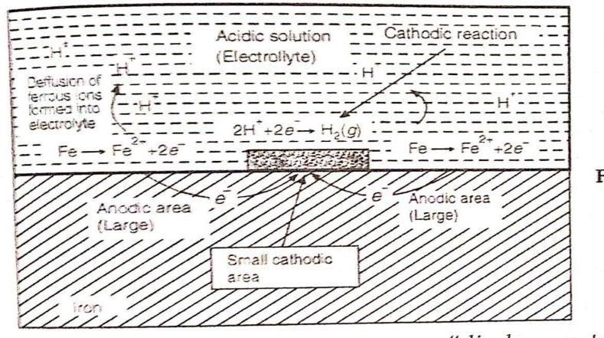
The electrons released flow through the metal from anode to cathode, whereas H⁺ ions ofacidic solution are eliminated as hydrogen gas.

Mechanism of wet corrosion- by hydrogen evolution
- Absorption of Oxygen: The rusting of iron takes place in neutral aqueous solution of electrolytes (like NaCl solution) in presence of atmospheric oxygen. If the metal surface develops cracks, anodic areas are created on the surface whereas the rest metal parts act as cathodes.
At anode Fe Fe²⁺ + 2e- (Oxidation) The released electrons flow from anode to cathode through iron metal.
At cathode ½ O2 + H2O + 2e⁻ 2OH⁻ (Reduction) Fe(OH)2 precipitate when Fe²⁺ and OH⁻ ions reacts with each other
Fe²⁺ + 2OH⁻ Fe(OH)2
If oxygen is in excess, ferrous hydroxide is easily oxidized to ferric hydroxide. 4Fe (OH)2 + O2 + 2H2O 4 Fe(OH)3
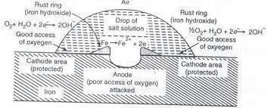
The product called yellow rust, actually corresponds to Fe2O3. 3H2O

Mechanism of wet corrosion- by Oxygen absorption Q2. Describe the determination of calorific value by Bomb Calorimeter.
A2. Principle- A known mass of fuel is burnt and the quantity of heat produced is absorbed in water which is measured. Bomb calorimeter is used to determine calorific value of solid and liquid fuels experimentally. Description: A bomb calorimeter contains a cylindrical bomb made by stainless steel. Combustion takes place in this cylinder. The lid contains two stainless steel electrodes. Oxygen is supplied through oxygen valve for combustion. The electrode is attached with a Mg wire which supports nickel or stainless steel made crucible. The bomb is taken in a copper calorimeter which is surrounded by air and water jacket in order to prevent heat loss by radiation. The copper calorimeter also contains electrically operated stirrer and Beckmann’s thermometer (take reading with temperature difference up to 0.01ºC).
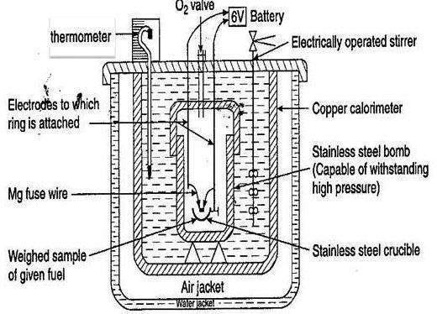
BOMB CALORIMETER
Working:
- In a crucible, a known amount of the fuel is placed in the nickel or stainless steel crucible.
- A Pt/ Mg wire connected with electrode which is touched with fuel.
- The bomb is filled with oxygen at about 25 atm pressure and covers the bomb tightly with lid.
- The Bomb is placed in copper calorimeter containing a known amount of water. The electrically operated stirrer is driven and notes the initial temperature of water (t1) by thermometer.
- Electrodes are connected to a battery to complete the circuit. The fuel sample is burn and heat is liberated which is absorb by water in copper calorimeter, water is continuously stirred and the final temperature (t2) of water is noted.

Observation
Mass of fuel (solid or liquid) = x g Mass of water taken = W g
Water equivalent of calorimeter = w g
Initial temperature of water in calorimeter = t1 K Final temperature of water in calorimeter = t2 K Calculation
Heat absorbed by the water = W (t2-t1) cal Heat absorbed by the calorimeter = w (t2-t1) cal
Total heat absorbed = W(t2-t1) + w(t2-t1) cal
= (W+w) (t2-t2) cal Heat liberated by the fuel =𝒙 x C
Heat liberated by the fuel =Total heat absorbed
𝒙 x C = (W+w) (t2-t1) cal
High or gross calorific value (C) = (W+w) (t2-t1) cal

𝒙
LCV = HCV – H/100 × 9 × 587 kcal/kg

Corrections:
To obtain accurate calorific value following corrections are include-
- Fuse wire correction- The measured heat also includes the heat given by ignition of fuse wire so this heat is subtracted from total value.
- Acid wire correction- During ignition sulphur and nitrogen oxidised to sulphuric and nitric acid along with evolution of heat, this heat is subtracted from total value.
- Cooling correction- The time taken to cool the hot water in calorimeter from maximum to room temp. is noted. From the rate of cooling and actual time taken for cooling, the cooling correction is added to rise in temp.
HCV = (W + w) {(t2 – t1)+cooling correction)}-(Acid correction +fuse wire correction)

Mass of the fuel x

Q3. Explain Otto Hoffmann by product oven method.
A3.Carbonization- The conversion of coal into coke by heating in absence of air is called carbonization. Principle- In order to increase the thermal efficiency of carbonization process and to recover the valuable by- products, Otto-Hoffmann developed a modern by-product coke oven.

Process-
- It consists of number of narrow silica chambers, each chamber being 10-12 m long 3-4 m height and 0.3
-0.45 m wide.
- Each chamber is provided with a charging hole at the top, a gas off-take and a refractory lined cast iron door at each end for discharging coke.
- Coal is introduced into the chamber and the chambers are closed. The ovens are heated to 1200°C by burning a gaseous fuel like producer gas and usually employ a regenerative principle to active economical heating.
- The fuel gases produced during combustion are passed to the regenerators having chequer brick work that takes up the heat and gets heated to about 1000°C. The flow of heating gases is the reversed so that the hot flue gases preheat the other chambers.
- Carbonization of the charge coal complete in 11 to 18 hours.
- When coke is formed, a massive ram pushes the red hot coke outside. It is subsequently quenched by wet quenching (spraying water) or dry quenching (passing inert gas N2). The coke obtained by dry quenching is drier, clean and stronger than wet quenched coke.

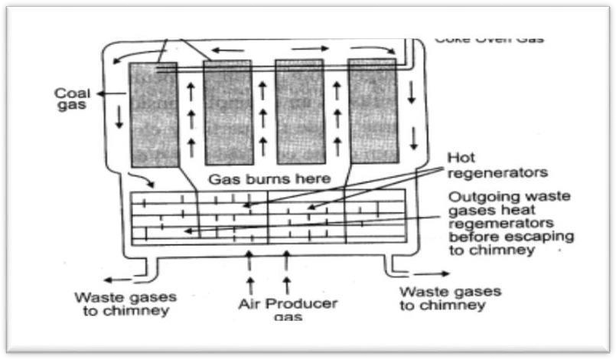

Otto-Hoffmann’s By-Product Oven

Recovery of By-products: Coke oven gas is mainly composed of NH3, H2S, Naphthalene, Benzene, tar and moisture.
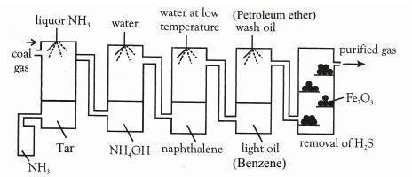

Recovery of By-products by coke oven gas
  - Recovery of Tar: The gas is first passed through a tower in which liquor ammonia is sprayed. Here dust and tar get collected in a tank below, which is heated by steam coils to recover back ammonia sprayed. The ammonia is used again.
  - Recovery of ammonia: The gases from the chamber are then passed into a tower in which water is sprayed. Ammonia dissolves in water to form ammonium hydroxide.
  - Recovery of naphthalene: The gases are allowed to pass into another tower in which water at very low temperatures sprayed such that the naphthalene is condensed.
  - Recovery of Benzene: The gases are then sprayed with petroleum ether to recover benzene.
  - Recovery of H2S: To recover hydrogen sulphide, the gases are allowed to pass through purifying chamber containing moist Fe2O3.
Fe2O3 + 3H2S →Fe2S3+3H2O Fe2S3 + 4O2 →2FeO+3SO2 4FeO +O2 →2Fe2O3

Q4. Explain Fixed bed and Moving bed catalytic cracking. A4. Fixed bed catalytic cracking:
- The heavy oil is passed through pre-heater at temp. 425-450°C then hot vapours formed.
- Hot vapours are passed over a fixed bed of catalytic chamber, in this chamber catalyst silica alumina gel present, during the passage through this tower, about 40 % of the charge is converted into gasoline in vapours form and about 2-4 % carbon is formed which one later gets adsorbed on the catalyst bed.
- Now cracked vapours are passed through a fractionating chamber where heavy oil separated and light fraction is passed through cooler where gasoline condensed along with some gases this is then sent to stabilizer where dissolved gases are removed and pure gasoline is obtained.
- The catalyst, after 8-10 hours, stops functioning, due to the deposition of black layer of carbon, formed during cracking. This is re-activated by burning off the deposited carbon.

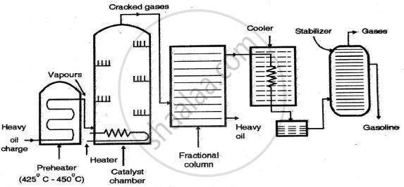

Fixed bed catalytic cracking

37
Moving bed or Fluidized bed catalyst cracking:
  - In moving bed catalytic cracking the feed oil is first passed through a pre heater, which converts oil into vapours.
  - The vapours of oil mixed with catalyst are forced up into a large reactor ‘bed’ in which cracking of the heavier hydrocarbon into lighter molecules.
  - Near the top of the reactor, there is a centrifugal separator which allows only the cracked oil vapours to pass on to fractionating column where heavy oil separated, but retains all the catalyst powder in the reactor itself. Light fraction is passed through cooler where gasoline condensed along with some gases this is then sent to stabilizer where dissolved gases are removed and pure gasoline is obtained.
  - The catalyst powder gradually becomes heavier, due to coating with carbon, and settles to the bottom, from where it is forced by an air blast to regenerator maintained at 600°C.
  - In regenerator, carbon is burnt and the regenerated catalyst then flows through a stand pipe for mixing with fresh batch of incoming cracking oil.
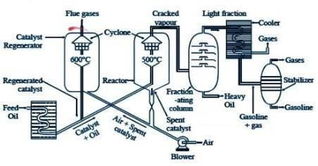
Moving bed or Fluidized bed catalyst cracking

Q5. Describe the determination of calorific value by Junker calorimeter.
A5. Principle- A known volume of gas fuel is burnt and the quantity of heat produced is absorbed in water which is measured. Junker calorimeter is used to determine calorific value of gases fuels experimentally.
Construction
- Junkers gas calorimeter consists of a combustion chamber surrounded by water jacket through this water jacket a number of tubes passes.
- A gas pipe line is connected with a burner kept in combustion chamber.
- A gas meter and pressure regulator is provided in a gas pipe line.
- Thermometers are used to measure the temperature of water at inlet, outlet and flue gas.
- Condensate from the gases is collected in condensate pot.

38
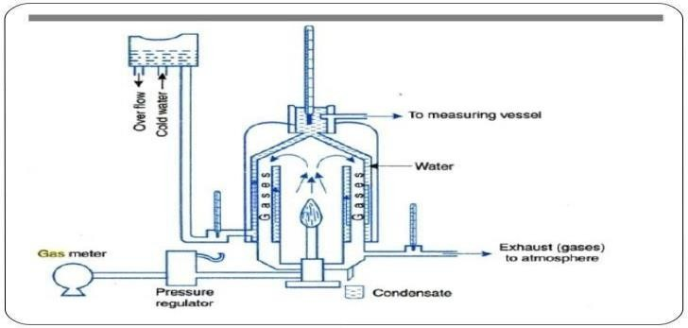
Junker’s calorimeter
Working:
- The gas whose calorific value is to be measured is supplied through a pipeline to the gas burner where it is burnt.
- The flow rate of gas is measured by a gas meter. The pressure of gas is measured by a manometer attached to the pressure regulator.
- The heat produced by combustion of gas is absorbed by the cold water passes through tubes present in water jacket.
- The gases are cooled up to room temperature as far as possible, so that entire heat released from the combustion may be absorbed by circulating water. The temperature of cooling water at inlet, outlet and exit gas temperature are measured.

Observations:
Volume of gas fuel burnt at given temp. and pressure =V Amount of water passes through the calorimeter =W (kg)
The mass of water (steam) condensed in the outlet water = m (kg) Temp.of inlet water = t1
Temp. of outlet water = t2 Higher calorific value of fuel =L
Calculation: heat absorbed by circulating water = W (t2-t1) Heat produced by the combustion of fuel = VL
Heat produced by the combustion of fuel = Heat absorbed by circulating water VL = W (t2-t1)

L(HCV) = W (t2-t1)/V
Lower calorific value = Higher calorific value – (m/V× 587) Kcal/m³

L.C.V = [L-m/V× 587] Kcal/m³

Q8. What do you means by galvanic and concentration cells? A8. Galvanic Corrosion:
This corrosion occurs when two dissimilar metals are connected and dipped in an electrolytic solution. It is also known as bimetallic corrosion.
When two metals having different electrode potentials are in contact with each other in the presence of an electrolyte, one metal acts as a cathode whereas the other acts as an anode. This leads to an electrochemical reaction as a result of which, the anode is dissolved into the electrolyte. This electrochemical process is called galvanic corrosion of metals.

Mechanism of Galvanic Corrosion
When two metals come in contact in the presence of an electrolyte, the more reactive metal acts as an anode whereas the less reactive metal acts as a cathode. Galvanic corrosion can be used beneficially to protect a cathodic metal from corrosion.

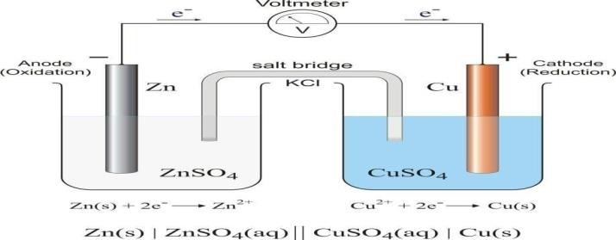

The metal higher in electrochemical series forms in anode and is corroded whereas the metal lower in galvanic series act as cathode and is protected.
Example- In case of Zn-Cu couple, Zn is corroded and Cu is protected.

Concentration Cell Corrosion:
Concentration cell corrosion occurs when two or more areas of a metal surface are in contact with different concentrations of the same solution. It is due to electrochemical attack on the metal surface, exposed to an electrolyte of varying concentrations. It occurs when one part of metal is exposed to a different air concentration from the other part. This causes a difference in potential between differently aerated areas. It has been found experimentally that poor-oxygenated parts are anodic.
\Example- If Zinc metal is partially immersed in a dilute solution of NaCl and the solution is not strirred, the parts above and loosely adjacent to the water line are well aerated and act as cathode. Area deep inside the solution are anodic, since the concentration of oxygen is smaller. Thus a potential is developed which causes a flow of current between two axes of thesame metal Zn dissolve at the anode area.
Zn Zn⁺² + 2e⁻
At the cathode area oxygen takes up electrons to form hydroxy ions-
½O2 + H2O + 2e⁻ OH⁻

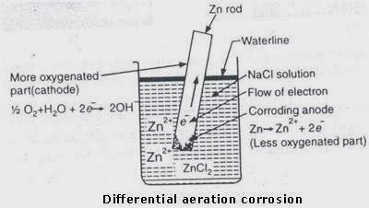

Q9. What is the basic composition of cement? Explain manufacturing of cement in detail with its proper diagram & reaction?
A9. Portland cement was discovered in 1824 by William Aspdin. Portland cement consist compound of lime, silica, alumina and iron. It forms a paste with water. This paste are hardens and binds aggregates (crushed rock, gravel sand etc) together to form a hard durable mass called Concrete. Portland cement is also known as “Magic powder”. Component of cement are Silica, Lime Iron oxide, magnesium oxide and alkali, etc

Manufacture of Portland cement:
Raw Material- The major raw material for manufacture of Portland cement are-
- Calcareous materials (CaCO3 containing materials such as lime stone, chalk, marble etc.
- Argillaceous materials (Silicate containing materials such as clay, shall, slate, furnace slag etc. 3) Gypsum (CaSO4.2 H2O)

Manufacturing of Portland cement by Rotary Kiln process having following steps:
- Mixing and crushing of raw materials (a. Dry process b. Wet process)
- Burning
- Grinding

Steps- Mixing and crushing of raw materials
(1.a) Dry process: · In the dry process calcareous material such as lime stone (calcium carbonate) and argillaceous material such as clay are ground separately to fine powder in the absence of water and then are mixed together in the desired proportions.
(1.b) Wet process: · In the wet process, the raw materials are changed to powdered form in the presence of water. The muddy mixture formed in this process is known as slurry. The slurry is then passed into storage tanks, then slurry is then fed into rotary kiln for burning.

(2) Burning-
The slurry of raw material enters from the upper ends of rotary kiln while the burning fuel i.e. coal dust or oil and air are introduced from the lower ends of kiln. The slurry gradually flows in the kiln into the different zones of increasing temp.
- The drying zone: The zone is present in upper part of kiln and temperature is around 400°C. Here water present in the slurry gets evaporated and clay is cleaved to Al2O3, SiO2 and Fe2O3.
Al2O3. SiO2. Fe2O3 2H2O Al2O3 + SiO2 + Fe2O3 .2H2O
- Calcinations’ zone or Decarbonating zone: This is middle portion of kiln, where the temperature is 1000°C. Here the lime stone is completely decomposed into CaO which exists in the form of small lumps called nodules.
CaCO3 → CaO + CO2
- Burning zone or clinkering zone: This is bottom most and hottest zone in rotary kiln. The temperature is around 1400°C-1500°C. In this zone the mixture melts and forms little rounded pasty mass called clinkers. The clinkers are greenish black and have rough texture. In the burning zone or
clinkering zone the following reactions take place.

2CaO + SiO2 → 2CaO.SiO2 (C2S) Dicalcium silicate 3CaO + SiO2 → 3CaO.SiO2 (C3S) Tricalcium silicate 3CaO + Al2O3→3CaO.Al2O3 (C3A) Tricalcium aluminate
4CaO + Al2O3 + Fe2O3 4CaO . Al2O3. Fe2O3 (C4AF) (Tetracalcium aluminoferrite)

- Grinding or mixing of cement clinkers with gypsum: The clinkers are cooled and finely ground. The finely ground clinkers have low setting time and by absorption of moisture they set quickly. To reduce rate of setting it is mixed with 2-3% gypsum (CaSO4.2H2O). The fast setting Al2O3 in clinkers reacts with gypsum and form crystals of tricalcium sulfoaluminate which is insoluble. This prevents early setting and hardening. The mixture of clinkers and gypsum is known as Portland cement.

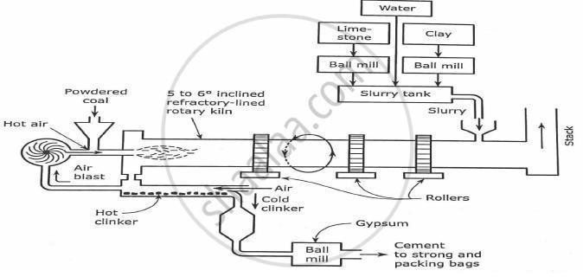

MANFACTURE OF PORTLAND CEMENT BY ROTARY KILN

Q10. What is glass? How it is manufactured? Explain annealing of glass?
A10.Glass is an amorphous, hard, brittle, transparent, super cooled, and liquid of infinite viscosity. It is obtained by fusing a mixture of sodium carbonate, calcium carbonate and sand.
Glass is a mixture of number of silicates and hence no definite chemical formula. However, it
Is sometimes represented as XM2O.y MO.SiO2 where M is a monovalent alkali metal like Na, K etc. M is a bivalent metal like Ca, Pb, Zn etc. And X and y are the whole number so ordinary glass may be represented as Na2O.CaO.6SiO2.

Glass Manufacturing
The manufacturing process of glass consists following steps:
- Formation of batch material
- Melting
- Shaping
- Annealing
- Finishing
- Formation of batch material - Raw materials in proper proportions (sand, soda ash and lime
stone) are mixed and finely powdered. The homogenous mixture known as Batch is fused with some broken glass, called “Cullet”. The cullets melt comparatively at low temperature and assist in the melting of rest of the charge.
- Melting – Melting of glass batch is done by heating either in pot furnace or tank furnace at temperature about 1800ºC. Heating is done by producer gas or regenerative method. In furnace at 1800ºC batch material melt and fused with hot gases on continue heating, On heating CO2 gas is escapes out and viscous fused mass is obtained (molten glass). When sample becomes transparent and free from bubbles of gas, the resulting mass is known as plain. Heating is now stopped and furnace is allowed to cool.
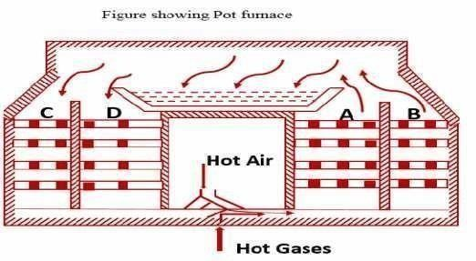

Manufacturing of Glass Chemical reactions in melting process:
Cullet melts at relatively low temperature and assists in melting of rest of the charge. During melting process following reactions occur.
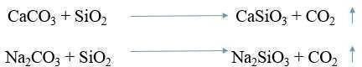

- Shaping: Molten glass is converted to desired shape by blowing or molding or pressing between rollers.
- Annealing: Articles are then cooled gradually at room temperature. The longer the annealing period better the quality of glass.
- Finishing: After annealing, the articles are subjected to cleaning, polishing, cutting etc.

Q11. Explain the principle of green chemistry.

A11.Principles of Green Chemistry-
This is true that green chemistry is an alternative tool for reducing pollution. Following principles justify the same:
  - Prevention: Preventing waste is better than cleaning up debris. It helps inefficient use of resources and prevents waste.
  - Atom Economy: Design syntheses so that the final product contains the maximum proportion of the starting materials. Waste few or no atoms.
  - Design less hazardous chemical syntheses: Design syntheses to use and generate substances with little or no toxicity to either humans or the environment.
  - Designing Safer Chemicals: Design chemical products that are fully effective yet have little or no toxicity.
  - Safer Solvents and Auxiliaries: Auxiliary substances should be avoided wherever possible and as non-hazardous as possible when they must be used.
  - Increase energy efficiency Run chemical reactions at room temperature and pressure whenever possible. Energy processes should be conducted at ambient pressure and temperature whenever possible.
  - Use of Renewable Feedstock’s: Renewable feedstocks or raw material should always be preferred to non- renewable whenever technically and economically practicable.
The source of renewable feedstocks is often agricultural products or the wastes of other processes; the source of depletable feedstocks is often fossil fuels (petroleum, natural gas, or coal) or mining operations.
  - Reduce Derivatives: Avoid using blocking or protecting groups or any temporary modifications if possible. Derivatives use additional reagents and generate waste.
  - Catalysis: Minimize waste by using catalytic reactions. Catalysts are effective in small amounts and can carry out a single reaction many times. They are preferable to stoichiometric reagents, which are used in excess and carry out a reaction only once.
  - Design for Degradation: Chemical products should be designed so that it does not have any harmful impact on the environment. Chemical products should be broken into non- toxic products.
  - Real-time Analysis for Pollution Prevention: Further development of analytical methodologies must be made to allow for real-time, in-process monitoring, and control before the formation of hazardous substances.
  - Minimize the potential for accidents: Design chemicals and their physical forms (solid, liquid, or gas) to minimize the potential for chemical accidents including explosions, fires, and releases to the environment.

Q12. Write notes on (A) Viscosity (B) Flash & Fire point A12. VISCOSITY
Viscosity - Viscosity is the property of a fluid that determines its resistance to flow. It is an indicator of flow ability of lubricating oil. The lower viscosity greater will be the flow ability. If temperature increases viscosity of the lubricating oil decreases and pressure increases viscosity of lubricating oil increases.
Consider two layers of a liquid separated by a distance, d and moving with a relative velocity difference, v. Then, force per unit area (F) required maintaining this velocity difference is given by: F = ŋ v /d
Where ŋ (eta) is a constant of a liquid, called viscosity coefficient. (i) if the viscosity of the oil is too
low. a liquid oil film cannot be maintained between two moving/sliding surfaces, and consequently, excessive wear will take place. On the other hand, (ii) If the viscosity is too high, excessive friction will result. The viscosity is temperature depending property.
The viscosity of an oil is measured by –
- Redwood viscometer No.1
- Redwood viscometer No.2
Both are identical and differ only in dimensions of orifice.

Essential parts of redwood viscometer are-
- Oil Cup: It is cylindrical brass oil cup (90 mm in height and 46.5mm in diameter) which is opened at the upper end. Oil has to be filled in it up to a certain mark. The bottom of the cup is fitted with a jet made up of ‘agate’ and can be opened by valve rod fitted with a ball made of brass. Thermometer is also provided to record the temperature.
- Heating Bath: The oil cup is surrounded by water bath for adjusting the temperature.
- Kohlrausch’s Flask: A calibrated receiving flask (Known as Kohlrausch flask) is provided for receiving the oil. Its capacity is 50 ml. up to mark in its neck.
- Stirrer: A stirrer, carrying four blades is fitted in water bath for maintaining the uniform desired temperature.
- Levelling screws- The entire apparatus rests on three legs provided at their bottom with leveling screws.
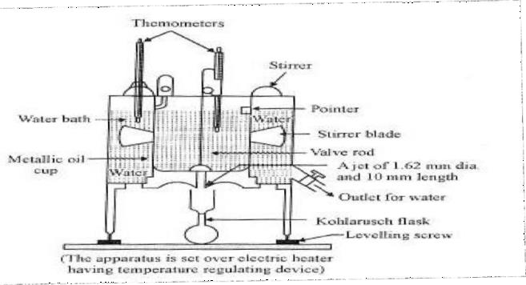
Redwood viscometer

Procedure:
- Select the Redwood viscometer No.1 to determine the viscosity of given sample of lubricating oil.
- Clean the oil cup with a sample solvent e.g. CCl4, ether, petroleum, spirit or benzene and dry to remove material inside.
- Level the viscometer by leveling screws.
- Fill heating bath with water and oil cup with oil.
- Seal the orifice properly by means of brass ball.
- Put the Kohlrausch’s flask below the jet.
- Maintain the desired temperature.
- Stirrer the contents of water bath and oil cup.
- At the equilibrium temperature, lift the ball and time is noted for 50 ml of oil collect in the flask.
- Replace the ball and seal the cup. Refill the oil cup. Perform the experiment to get reproducible results.
- Repeat the experiment at three different temperatures and note respective times.

FLASH AND FIRE POINT
Flash point - The flash point of a volatile material is the lowest temperature at which vapours of the material will ignite for a moment when an ignition source brought near to it. The lubricating oil should have flash point reasonably above its working temperature.
Fire point: The fire point of a fuel is the lowest temperature at which the vapour of that fuel will continue to burn for at least 5 seconds when an ignition source brought near to it. Fire point is around 10°C higher than flash point.
Theory: -The good lubricating oil should not volatize under the working temperatures. Even if some voltization takes place, the vapours formed should not form inflammable mixture with air under the lubrication conditions. From this point of view, the study of flash and fire point of lubricating oil is of significance for industrial applications. Lubricating oil should have these points reasonably above its working temperature to ensure safety against fire hazards.

Description of Apparatus:
Pensky Marten’s apparatus is a closed cup apparatus used for the determination of flash and fire points of the lubricating oil. It consists of following parts.
- Oil cup: It consists of a brass cup (5 cm diameter, 5.5 cm depth) having standard size.
- Lid of the oil cup: The lid has four openings, which are mean for stirrer, thermometer an air inlet and a device for introducing the standard flame.
- Air Bath-Oil cup is surrounded by its flange over and air bath which is heated electrically.
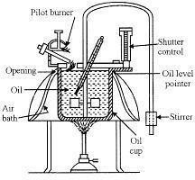
Pensky Martens’ apparatus
- Electric heater: The assembly is kept on electric heater which can be heated in a controlled manner.

Procedure:
  - Clean and dry the oil cup.
  - Fill the cup with a given sample of oil.
  - Cover the lid and insert thermometer, stirrer and flame exposure device on the top.
  - The apparatus is heated so that the oil temperature increases by 5-6℃ per minute while the stirrer is rotated at approx. 60 revolutions per minute.
  - When the temperature is within the range of anticipated flash point, the test flame is brought near oil vapours for about 2 sec at every degree rise of temperature.
  - Record the flash point at the temperature at the time when test flame applied causes distinct flash.
  - The oil sample is further heated at the rate of about 1℃/minute and application of test flame is done after every 1℃ rise in temperature of oil. The temperature at which vapour of oil give clear and distinct flame for at least 5 seconds is recorded as its fire point.

Significance:
    - The flash point does not indicate directly the lubricating value of oil but it is important when the oil is exposed to high temperature.
    - Oil of high flash point is supposed to offer more resistance to spontaneous combustion.
    - The knowledge of flash and fire point of lubricant oil in precautionary measures against fire hazards.

Q13. Write notes on-
- Cloud & Pour point

Waste and pollution prevention hierarchy
A13. (A)CLOUD AND POUR POINT
Cloud Point - The temperature at which lubricating oil becomes cloudy in appearance is called cloud point.
Pour Point - The lowest temperature at which the lubricant oil become semi-solid and ceases to flow is called pour point. It indicates the suitability of lubricants used in cold condition. Good lubricant should possess low pour point.
Principle: Lubricating oils obtained from crude oil usually contains dissolved paraffin wax and other such substances which have a tendency to crystallize and separate out at lower temperature affecting the lubricating properties.
Cloud and pour point apparatus is used for the determination of cloud and pour points of oil. It consists of following parts.
  - Test tube: It is glass tube having flat bottom and standard dimension (3 cm diameter12 cm height).
  - Cooling bath: It consists of insulated jackets of glass or copper containing cooling mixture (here it is ice).
  - Thermometers: In given sample and cooling mixture, two thermometers are fitted.
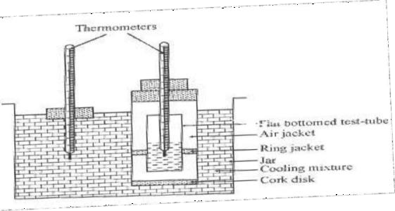

Cloud & Pour Apparatus
Procedure:
- Thoroughly dry and clean flat bottomed glass tube.
- Fill the oil sample and fit the cork.
- Adjust the dipped bulb of thermometer in the oil and in the cooling bath.
- Keep the glass tube in cooling mixture.
- The temperature of oil falls on cooling. Take out the tube after every 1 ℃ fall in temperature and inspect for a moment. It may restore if the cloudiness has not appeared.
- For cloud point, note the temperature for hazy appearance.
- For pour point, continue the cooling process. After every 3℃ fall, the tube is withdrawn and tilted to horizontal position for about 5-10 seconds. Note the temperature when oil slops following. It is the pour point of given oil sample.

Significance of cloud and pour point:
- The cloud point indicates stability of lubricants in cold conditions.
- Cloud point is useful for estimating the temperature at which filter screens in the fuel intake system of diesel engine clogged because of separation of wax.

B) Waste and Pollution prevention hierarchy

Pollution prevention is the reduction or elimination of wastes and pollutants at their sources. For all the pollution that is avoided in the first place, there is that much less pollution to manage, treat, dispose of, or clean up.
The waste hierarchy is a simple ranking system used for the different waste management options according to which are the best for the environment.
The Pollution Prevention Act of 1990 explains clearly the hierarchy as follow:

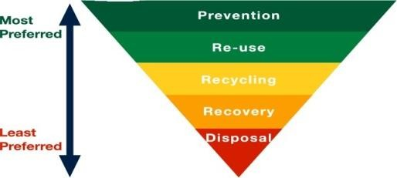

Prevention
It is the most desirable option of the hierarchy and the most effective way to reduce risk. Pollution should be prevented or reduced at the source whenever feasible.

Reuse
When waste is created, the waste hierarchy priorities reuse. Where possible, reusing waste reuse (for example, refilling a drinks bottle), followed by recycling (processing of wastes into new raw materials).

Recycling
Pollution that cannot be prevented should be recycled in an environmentally safe manner whenever feasible.

Recovery
The recovery of energy by burning or biological treatment. Composting is also a method we use when we can't recycle materials. Composting turns organic wastes into nutrient- rich food for plants.

Disposal
Land filling is the final option for any wastes that cannot be dealt with in any other way. A landfill site is an area of land set aside for the final disposal of solid waste.

Q15. Write notes on-
  - Lime soda method

Ion exchange method

A15. Lime soda process is two types.
Cold Lime –Soda (L-S) process: In this method, calculated quantities of lime and soda are mixed with water at room temperature. There are two kind of softener used for softening process-
- Intermittent type (Batch process)- In this process hard water and calculated amount of lime and soda are mixed with the help of stirrers. Then soluble quantity of coagulants like sodium aluminate is added for setting the produced precipitate. The softened water is taken out through an exit pipe.
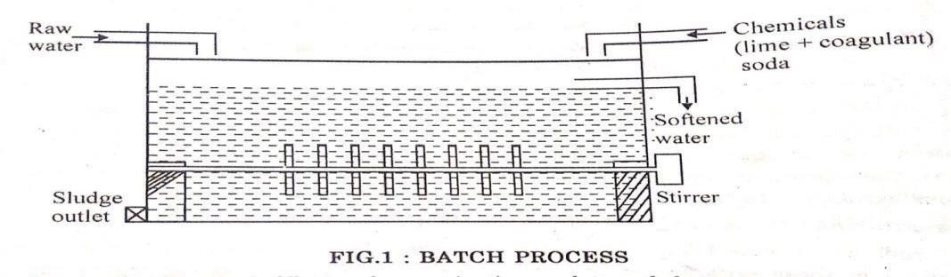
- Continuous Softener- This softener consists of a big steel tank with two chambers. The inner chamber is provided with a stirrer and outlet chamber has wood fiber filters to remove the fine particle of sludge. The raw water is passed into a inner tank with a static continuous flow, at the same time a calculated amount of chemical mixture of lime and soda ash are also added and then
thoroughly mixed with a stirrer in this mixture tank after that water is allowed to settle. When the settlement becomes complete the water is passed by continuous up-flow process into another tank which is called filter bed. Then we get soften water.
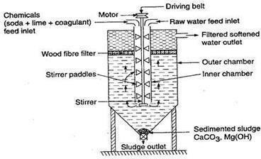

Continuous Cold Lime –Soda Softener

The cold lime soda process is not suitable for all purposes. It is limited for those purposes where partially softened water needed because this process fails to precipitate completely all the hardness forming salts. The cold lime soda process is used for municipal water and cooling water softener systems.

Hot lime soda process
In the hot lime soda process the reactions take place at higher temperature near about boiling point of water (80- 150ºC). The chemical mixing process is same as the cold lime soda process, but steam is applied in mixture tank. As a result precipitation becomes almost complete very quickly.
In this process continuous softener consist three parts-
  - Reaction tank- Raw water and chemicals are fed into this tank. Reactions start sand also complete in this tank
  - Settling tank- From the reaction tank, transfer into this tank where sludges settle down and removed by opening sludge valve.
  - Sand filter- Clear and soften water from settling tank passes to sand filter which remove suspended particle and precipitate.
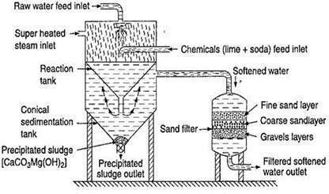

Continuous Hot Lime –Soda Softener

Advantages:-
- Lime –soda process is more economical.
- Less amount of coagulant is required.

Disadvantages:-
- Careful operation & skilled supervision are required.
- Disposal of large quantity of sludge formed during process is a problem.

Ion Exchange Process (Deionization or Demineralization): Ion exchange is a process of complete removal of all the ions present in water. Exchange of ions takes place between a solid (resins) and liquid (water) phase.
Ion exchange resins are organic, cross linked, insoluble polymers having acidic or basic functional groups and are capable to exchange reversibly their H⁺/OH⁻ ion with hardness producing ions.
There are two general types of ion exchange resins:

Cation Exchange Resins
  - Anion Exchange Resins
- Cations Exchange Resins (R⁻H⁺): These resins exchange positive ions called cation exchange resins. A cation is an ion with a positive charge. These resins contain acidic groups like SO3H, - COOH or –OH (phenolic) groups etc.

2R-COOH + Ca⁺² (RCOO)2Ca + 2H⁺
- Anion Exchange Resins (R⁺OH⁻): The resins that exchange negative ions called Anion exchange resins. An anion is an ion with a negative charge. These resin containing functional groups like – NH2, -NH(CH3)2 etc .
2R’(OH)2 + SO4⁻² R’SO4⁻²+ 2OH⁻
Process-
The ion exchange softener consists of two tanks. The first tank contains cation exchanger and second contains anion exchanger.
The hard water first pass through cation exchange resin which exchanges its H⁺ ions for Ca⁺²and Mg⁺² ions in water.
2R’H + CaCO3 R’2Ca + H2CO3
2R’H + CaSO4 R’2Ca + H2SO4 ( R’ = RCOO⁻, RSO3-, RO⁻ )
Now water passing through anion exchanger tank. Hence the anion like SO4-2, Cl⁻ etc. present in
water is exchanged by OH⁻ ions of the resin.
ROH + Cl⁻ RCl + OH⁻
2ROH + SO4⁻² R2SO4 +2OH-
Thus water coming from after anion exchanger free from cations and anions which are responsible for hardness.
H⁺ ions released from cation exchanger and OH⁻ ions released from anion exchanger combine to form unionized water.
H⁺ +OH⁻ H2O
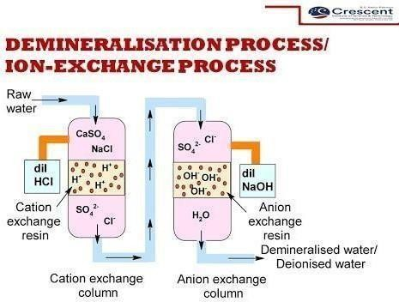

Regeneration
The “reactivation” process is called regeneration and is carried out using a strong acid for the cation (as a source of hydronium ions) and liquid caustic (sodium hydroxide) as a source of hydroxyl ions for the anion.
R’2Ca + H2SO4 2R’H + CaSO4
R’SO4 + NaOH R’(OH)2 + Na2SO4

Advantage of Ion Exchange Process:
- Highly acidic or alkaline water can be treated by this process.
- This produces water of very low hardness nearly 2 ppm.

Disadvantage of Ion Exchange Process:
- The equipment is costly and more expensive chemical are required.
- If water contains turbidity then the output of the process is reduced.

Q16. Write notes on-
- Use of ultrasonic energy

Use of microwaves
A16. Use of ultrasonic energy
Ultrasound energy, simply known as ultrasound, is a type of called sound characterized by vibrating or moving particles within a medium. Ultrasound is the term used for sound waves in the frequency range 16 kHz to 10 MHz. The applications of ultrasound are:
- Ultrasound fields with high frequency (> 2 - 5 MHz) and low intensity are used in diagnostic medicine.
- Ultrasound methods have been used for decades for testing materials, for example for testing weld seams or for locating hidden cracks in construction parts.
- Formation of emulsions and the displacement of dirt from surfaces, both for cleaning and activation. For example, ultrasonic baths are used for cleaning purposes.
- Sensitive surfaces, such as the lenses of glasses, can be cleaned without damaging them in this way. This process also has advantages for deposits that are not easily accessible, but have to be
removed. For these reasons, ultrasound baths are used by both opticians and many natural science laboratories.
- Other applications can be mentioned here: the smashing of kidney stones, the initiation or acceleration of radical reactions, the degradation of organic contaminants in polluted water.

B) Use of microwaves
When the wavelength is in the range 1 mm to 1 m (300 MHz to 300 GHz), is called microwaves. Microwaves are propagated in a vacuum at the speed of light, like any other form of electromagnetic radiation however, they are reflected by metal surfaces. As a result of this property, microwaves can be screened effectively using metal sheets and even close-meshed wire nets. The metal casing and the perforated sheet at the front of household microwave ovens screen the microwaves.
Microwave energy is an alternative energy source and fundamentally different method of transferring energy from source to sample. Microwave energy used for—
- Production of alloys and for melting metals
  - For glass production
  - For food processing
  - For analytical chemistry
  - For vulcanization for rubber
  - For wireless networks, radar, satellite and space communication
  - Medical diathermy, cancer treatment

